Department for Environment, Food and Rural Affairs  Scottish Government  Welsh Government |  |  |  |  |  | 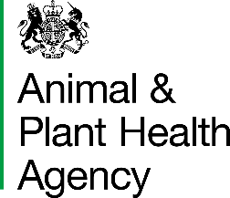
Animal Health Act 1981  The Brucellosis (England) Order 2015  The Brucellosis (Scotland) Order 2009  The Brucellosis (Wales) Order 2006 |  |  |  |  |  | APHA office

Brucellosis Blood Sample Report - Continuation Sheet
 | Sheet number |  |  |  | Lab ref. no. |  |  | Date received by lab
To be completed by the sender:
Name of herd owner |  |  |  |  |  |  |  |  | CPHH No.
Please use BLOCK LETTERS and BLACK INK
Breed | Age | Sex (M/F) |  | Official Animal Identity |  |  |  |  |  | Sample Barcode |  |  | Post Import Calving Date*
Name of herd owner |  |  |  |  |  |  |  |  | CPHH No.
Please use BLOCK LETTERS and BLACK INK
Breed | Age | Sex (M/F) |  | Official Animal Identity |  |  |  |  |  | Sample Barcode |  |  | Post Import Calving Date*
*Optional
Animal Health is an Executive Agency of the Department for Environment, Food and Rural Affairs and also works on
behalf of the Scottish Executive, Welsh Assembly Government and Food Standards Agency.

APHA is an Executive Agency of the Department for Environment, Food and Rural Affairs and also works on behalf of the Scottish Government, Welsh Government and Food Standards Agency to safeguard animal and plant health for the benefit of people, the environment and the economy.

HM3 Stamp | Name: |  | Date Received: |  | WS ID:

