Welsh Government | 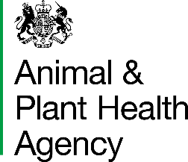
Cymorth Tuberculosis On-Farm Veterinary Advice and Assessment Checklist

The purpose of the on-farm visit is, for you the vet:

- to discuss the Tuberculosis (TB) situation on the farm with the farmer and provide support
- to provide the farmer with further information on the disease and breakdown process
- to provide advice on biosecurity and protecting the herd from disease introduction and spread
- to assess and advise the farmer on future options in terms of business continuity (if under restrictions)
- to investigate management on the farm and biosecurity on the premises in order to assess risks for disease spread and to give advice on reducing risks
- to identify potential sources, risk factors and objectives for eradicating disease on the holding and protecting the locality and to make recommendations to both the farmer and to Animal and Plant Health (APHA) and Welsh Government (WG).
- to advise the farmer on best practice to reduce the likelihood of a further breakdown.

As a rule of thumb at least 70% of the visit should be taken up touring the farm, walking the boundary where possible, and discussing issues identified with the farmer.

The following checklist is not meant to be prescriptive but should guide the conversation on some of the most important issues regarding TB. We encourage you to make recommendations for further action if you believe there is a specific intervention which could help clear up a breakdown or reduce the risk of a further breakdown.

Both you and the herd keeper should sign this form as a record of the conversation and visit. A signed hard copy should be given to the herd keeper, so they have a summary of recommendations for action. A further copy should be sent back to APHA (see address in the attached guidance note).

Farm Details

Name of Herd Keeper:
Address: | Postcode:
Name of Owner/Address
(if different):
Contact Details for holding:
CPH Number:
Type of holding (main):
TB incident number:

Cymorth TB Sam WS number:

Type of visit: Delete as appropriate | Breakdown/Breakdown concluded/Keep it Out
Date of visit:

 |  | Yes | No
The TB test – does the herd keeper understand: | a. Test results and effect on the current TB status
The TB test – does the herd keeper understand: | b. TB restrictions, if applicable
The TB test – does the herd keeper understand: | c. Timetable for post mortem examination PCR/culture and significance of these results, if applicable
The TB test – does the herd keeper understand: | d. Test sensitivity (including standard/severe interpretation) and inconclusive reactors
The TB test – does the herd keeper understand: | e. The type and date of the next test
Type of herd and farm business – have you considered and investigated the: | a. Herd size and type
 | b. Business continuity requirements
Cleansing and disinfection (C&D) | a. Is the farmer aware of the requirement to use a disinfectant that is approved for TB at the correct dilution?
Cleansing and disinfection (C&D) | b. Is the farmer aware of the requirement to return the tear off slip on the BT05, if under restrictions

Notes

Useful contacts, sources of advice and information

Cattle keepers' guide to safeguarding health  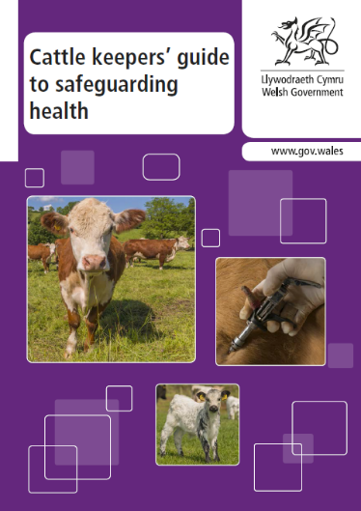 | 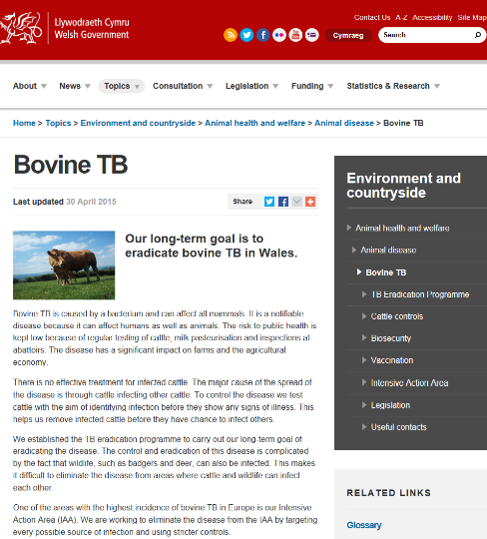  Welsh Government website on bovine TB
Dealing with TB in your herd  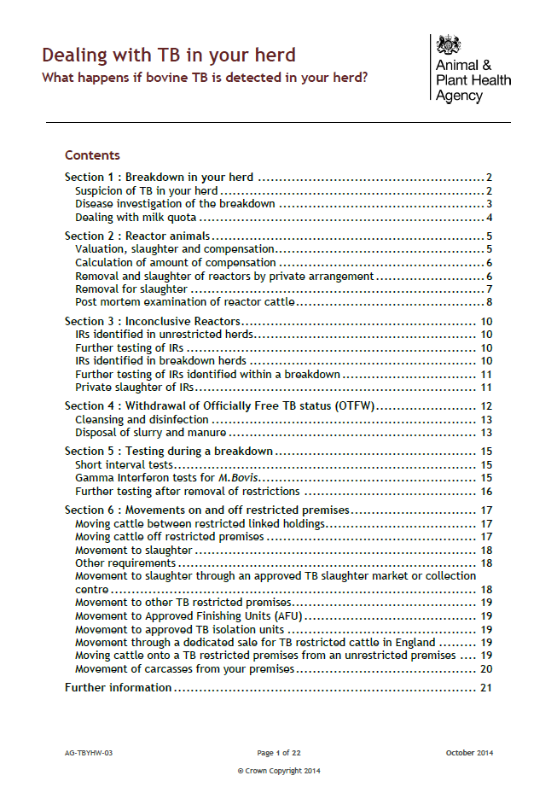 | GOV.UK website on bovine TB  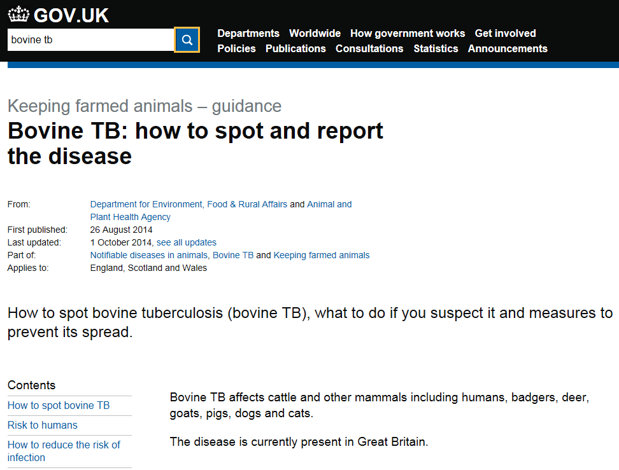

Risk factors and control measures

- Cattle – movements

Have you reviewed…? | Do these risk factors play a role on this farm? |  |  | If yes, can the farm apply these suggested control measure(s)  If breakdown visit consider if farm will apply, or if concluded breakdown visit, consider if farm did apply. | Yes - always | Mostly - more than half the time | Partly - less than half the time | No - never
Have you reviewed…? |  | Yes | No
Cattle - movements  Introduction of cattle (to include number and type introduced in normal situations, source(s) of cattle, locality and TB incidence at source of purchased cattle, age of cattle, type of preventative measures, benefits of AI and closed herd) | Frequent purchase of cattle |  |  | Can the farm adopt a closed herd policy with all replacements homebred?
 | Purchased replacement cattle (e.g. dispersal sales) |  |  | Can all replacement cattle be pre-movement tested before moving into the herd?
 | Direct introduction of purchased cattle into the herd |  |  | Can all purchased cattle be isolated and post-movement tested before introduction to the herd?
 | Use of hire bulls |  |  | Can the farm use AI or own bull?
 | Notes on recommendations and agreed action

- Cattle – contiguous

Have you reviewed…? | Do these risk factors play a role on this farm? |  |  | If yes, can the farm apply these suggested control measure(s)¹  If breakdown visit consider if farm will apply, or if concluded breakdown visit, consider if farm did apply. | Yes - always | Mostly - more than half the time | Partly - less than half the time | No - never
Have you reviewed…? |  | Yes | No
Cattle – contiguous  Mixing of herds and contact with other cattle (to include use of common or shared grazing, direct contact with neighbouring cattle, cattle returning from shows or markets, use of shared yard areas or testing facilities) | Contact with neighbouring cattle |  |  | Can the farm maintain secure boundaries to prevent nose to nose contact and straying with neighbouring cattle?
 | Use of shared grazing |  |  | Can the farm avoid the use of shared grazing?
 | Notes on recommendations and agreed action
- Cattle – residual infection

Have you reviewed…? | Do these risk factors play a role on this farm? |  |  | If yes, can the farm apply these suggested control measure(s)  If breakdown visit consider if farm will apply, or if concluded breakdown visit, consider if farm did apply. | Yes - always | Mostly - more than half the time | Partly - less than half the time | No - never
Have you reviewed…? |  | Yes | No
Cattle – residual infection  History of bTB incidents and testing in the herd (including presence of Inconclusive Reactors (IR) and other higher risk cattle and that all testing is up to date) | Repeated IR cattle may pose an increased risk |  |  | Can the farm voluntarily cull IR cattle?
 | Incomplete isolation of IR cattle |  |  | It is a statutory requirement for all IR cattle to be kept in isolation.
 | Incomplete or overdue testing |  |  | Can the farm complete all testing as scheduled, including gamma testing if appropriate?
 | Notes on recommendations and agreed action
- Badgers

Have you reviewed…? | Do these risk factors play a role on this farm? |  |  | If yes, can the farm apply these suggested control measure(s)  If breakdown visit consider if farm will apply, or if concluded breakdown visit, consider if farm did apply. | Yes - always | Mostly - more than half the time | Partly - less than half the time | No - never
Have you reviewed…? |  | Yes | No
Badgers  Contact with wildlife (to include location of badger setts and latrines, grazing systems used and possible contact at pasture, preventative measures when feeding at pasture and water supply at pasture, possible direct and indirect contact within the farm buildings, cattle housing, feed and silage stores, and other feeding practices that may encourage badgers, for example feeding other species at pasture such as lamb creep or game bird feeders. | Cattle contact (direct and indirect) with badgers at pasture |  |  | Can the farm put measures in place to prevent contact with badgers at pasture – can setts and latrines be fenced off?
 | Cattle contact (direct and indirect) with badgers in farm buildings? |  |  | Can the farm keep feed stores secure from access by badgers?
 |  |  |  | Can the farm keep silage stores/clamps secure from access by badgers?
 | Mineral lick and/or feed/water trough accessible by badgers |  |  | Can feed troughs, mineral licks and water troughs be raised off the ground so inaccessible to badgers at pasture? (With consideration to water trough height where sheep co-graze fields).
 | Notes on recommendations and agreed action

This page has been left blank and can be used for a sketch of the farm yard to help identify badger and other wildlife access points to buildings etc. Other animals
- Other animals

Have you reviewed…? | Do these risk factors play a role on this farm? |  |  | If yes, can the farm apply these suggested control measure(s)  If breakdown visit consider if farm will apply, or if concluded breakdown visit, consider if farm did apply. | Yes - always | Mostly - more than half the time | Partly - less than half the time | No - never
Have you reviewed…? |  | Yes | No
Other animals  Are there other livestock or domestic animals on the farm? | Other co-located livestock (for example, camelids, pigs, goats and deer) |  |  | Can the farm securely keep all other livestock species away from the cattle herd?
 | Other domestic animals (cats) |  |  | Can the farm securely keep domestic animals away from the cattle herd?
 | Notes on recommendations and agreed action
- Indirect

Have you reviewed…? | Do these risk factors play a role on this farm? |  |  | If yes, can the farm apply these suggested control measure(s)  If breakdown visit consider if farm will apply, or if concluded breakdown visit, consider if farm did apply. | Yes - always | Mostly - more than half the time | Partly - less than half the time | No - never
Have you reviewed…? |  | Yes | No
Indirect  To include management of slurry and manure, shared equipment, contractors, farm staff and visitors | Slurry or manure spread on grazing pasture |  |  | Can the farm avoid grazing cattle on pasture for at least 60 days after spreading of slurry or manure?
 | Shared machinery for slurry or manure spreading |  |  | Can the farm avoid use of shared machinery for slurry or manure spreading?
 | Poor cleanliness of cattle buildings and equipment |  |  | Can the farm regularly cleanse and disinfect cattle buildings and equipment?
 | Shared livestock transport and farm equipment |  |  | Can the farm avoid use of shared livestock transport and farm equipment?
 | Poor disinfection of shared livestock transport and equipment |  |  | Can the farm ensure thorough cleansing and disinfection of any shared livestock transport and equipment?
 | Farm staff and visitors |  |  | Can the farm provide farm staff and visitors with protective clothing?
 | Poor disinfection of protective clothing and provision of boot dips |  |  | Can the farm provide disinfection foot dips and disinfection of protective clothing?
 | Notes on recommendations and agreed action
- Other

Have you reviewed…? | Do these risk factors play a role on this farm? |  |  | If yes, can the farm apply these suggested control measure(s)  If breakdown visit consider if farm will apply, or if concluded breakdown visit, consider if farm did apply. | Yes - always | Mostly - more than half the time | Partly - less than half the time | No - never
Have you reviewed…? |  | Yes | No
Other  Delivery of a herd health plan and calf management | Feeding raw milk to calves |  |  | Can the farm feed replacement milk powder to calves or ensure milk is pasteurised before feeding to calves?
Other  Delivery of a herd health plan and calf management | Poor herd health status and concurrent endemic disease |  |  | Can the farm maintain an up-to-date herd health plan to support low levels of endemic and production disease?
Other  Delivery of a herd health plan and calf management | Increasing herd size |  |  | Can the farm introduce separate management groups to reduce risk of spread?
Other  Delivery of a herd health plan and calf management | Notes on recommendations and agreed action
- Additional risk factors

Have you reviewed…? | Risk factors and suggested control measure(s) for introduction or spread of TB
Are there any additional risk factors and control measures that can be identified on this farm? | Notes on recommendations and agreed action

Recommendations for further action

Please complete the template below with all recommendations made following this visit.

- Recommendations to the farmer

Having assessed the risk factors for this farm, in brief, what are the priority recommendations for practical control measures to support bTB eradication from the herd?

Risk factor category | Recommendation(s)
- Cattle - movements

- Cattle - contiguous

- Cattle - residual infection

- Badgers

- Other animals

- Indirect

- Other

- Additional risk factors

2. Recommendations for WG and APHA to consider

I have carried out a Cymorth TB support and advice visit and this report reflects my discussion with the farmer and provides a record of my recommendations/advice to the farmer:

Signature
Name in  BLOCK LETTERS |  | Date

Official Veterinarian (OV) Practice

I have received a Cymorth TB support and advice visit and this report is a good representation of our conversation and the recommendations made to me:

Signature |  | Owner/Keeper
Name in  BLOCK LETTERS |  | Date

APHA is an Executive Agency of the Department for Environment, Food and Rural Affairs and also works on behalf of the Scottish Government, Welsh Government and Food Standards Agency to safeguard animal and plant health for the benefit of people, the environment and the economy.

