Department for Environment, Food and Rural Affairs  Scottish Government  Welsh Government | 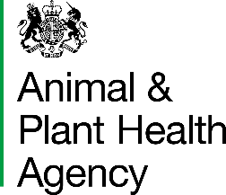
Certificate of Tuberculin Testing by Official Veterinarian/Veterinary Head of Field Delivery/Veterinary Lead Scotland/Veterinary Lead Wales

This is to certify that on
the following animal(s) were subjected to a single intradermal comparative tuberculin test using Lelystad avian and mammalian tuberculins and that in my opinion this/these animal(s) passed the test.

Description of Cattle
Official animal identity | Further Identification
Official animal identity | Breed | Age | Sex

Signature
Name in  BLOCK LETTERS |  | Date

Official Veterinarian of APHA

I agree with the above interpretation

Signature
Name in  BLOCK LETTERS |  | Date

Veterinary Head of Field Delivery/Veterinary Lead Scotland/Veterinary Lead Wales

DATA PROTECTION
For information on how we handle personal data please go to www.gov.uk and search Animal and Plant Health Agency Personal Information Charter.

APHA is an Executive Agency of the Department for Environment, Food and Rural Affairs and also works on behalf of the Scottish Government, Welsh Government and Food Standards Agency to safeguard animal and plant health for the benefit of people, the environment and the economy.

HM3 Stamp | Name: |  | Date Received: |  | WS ID:

